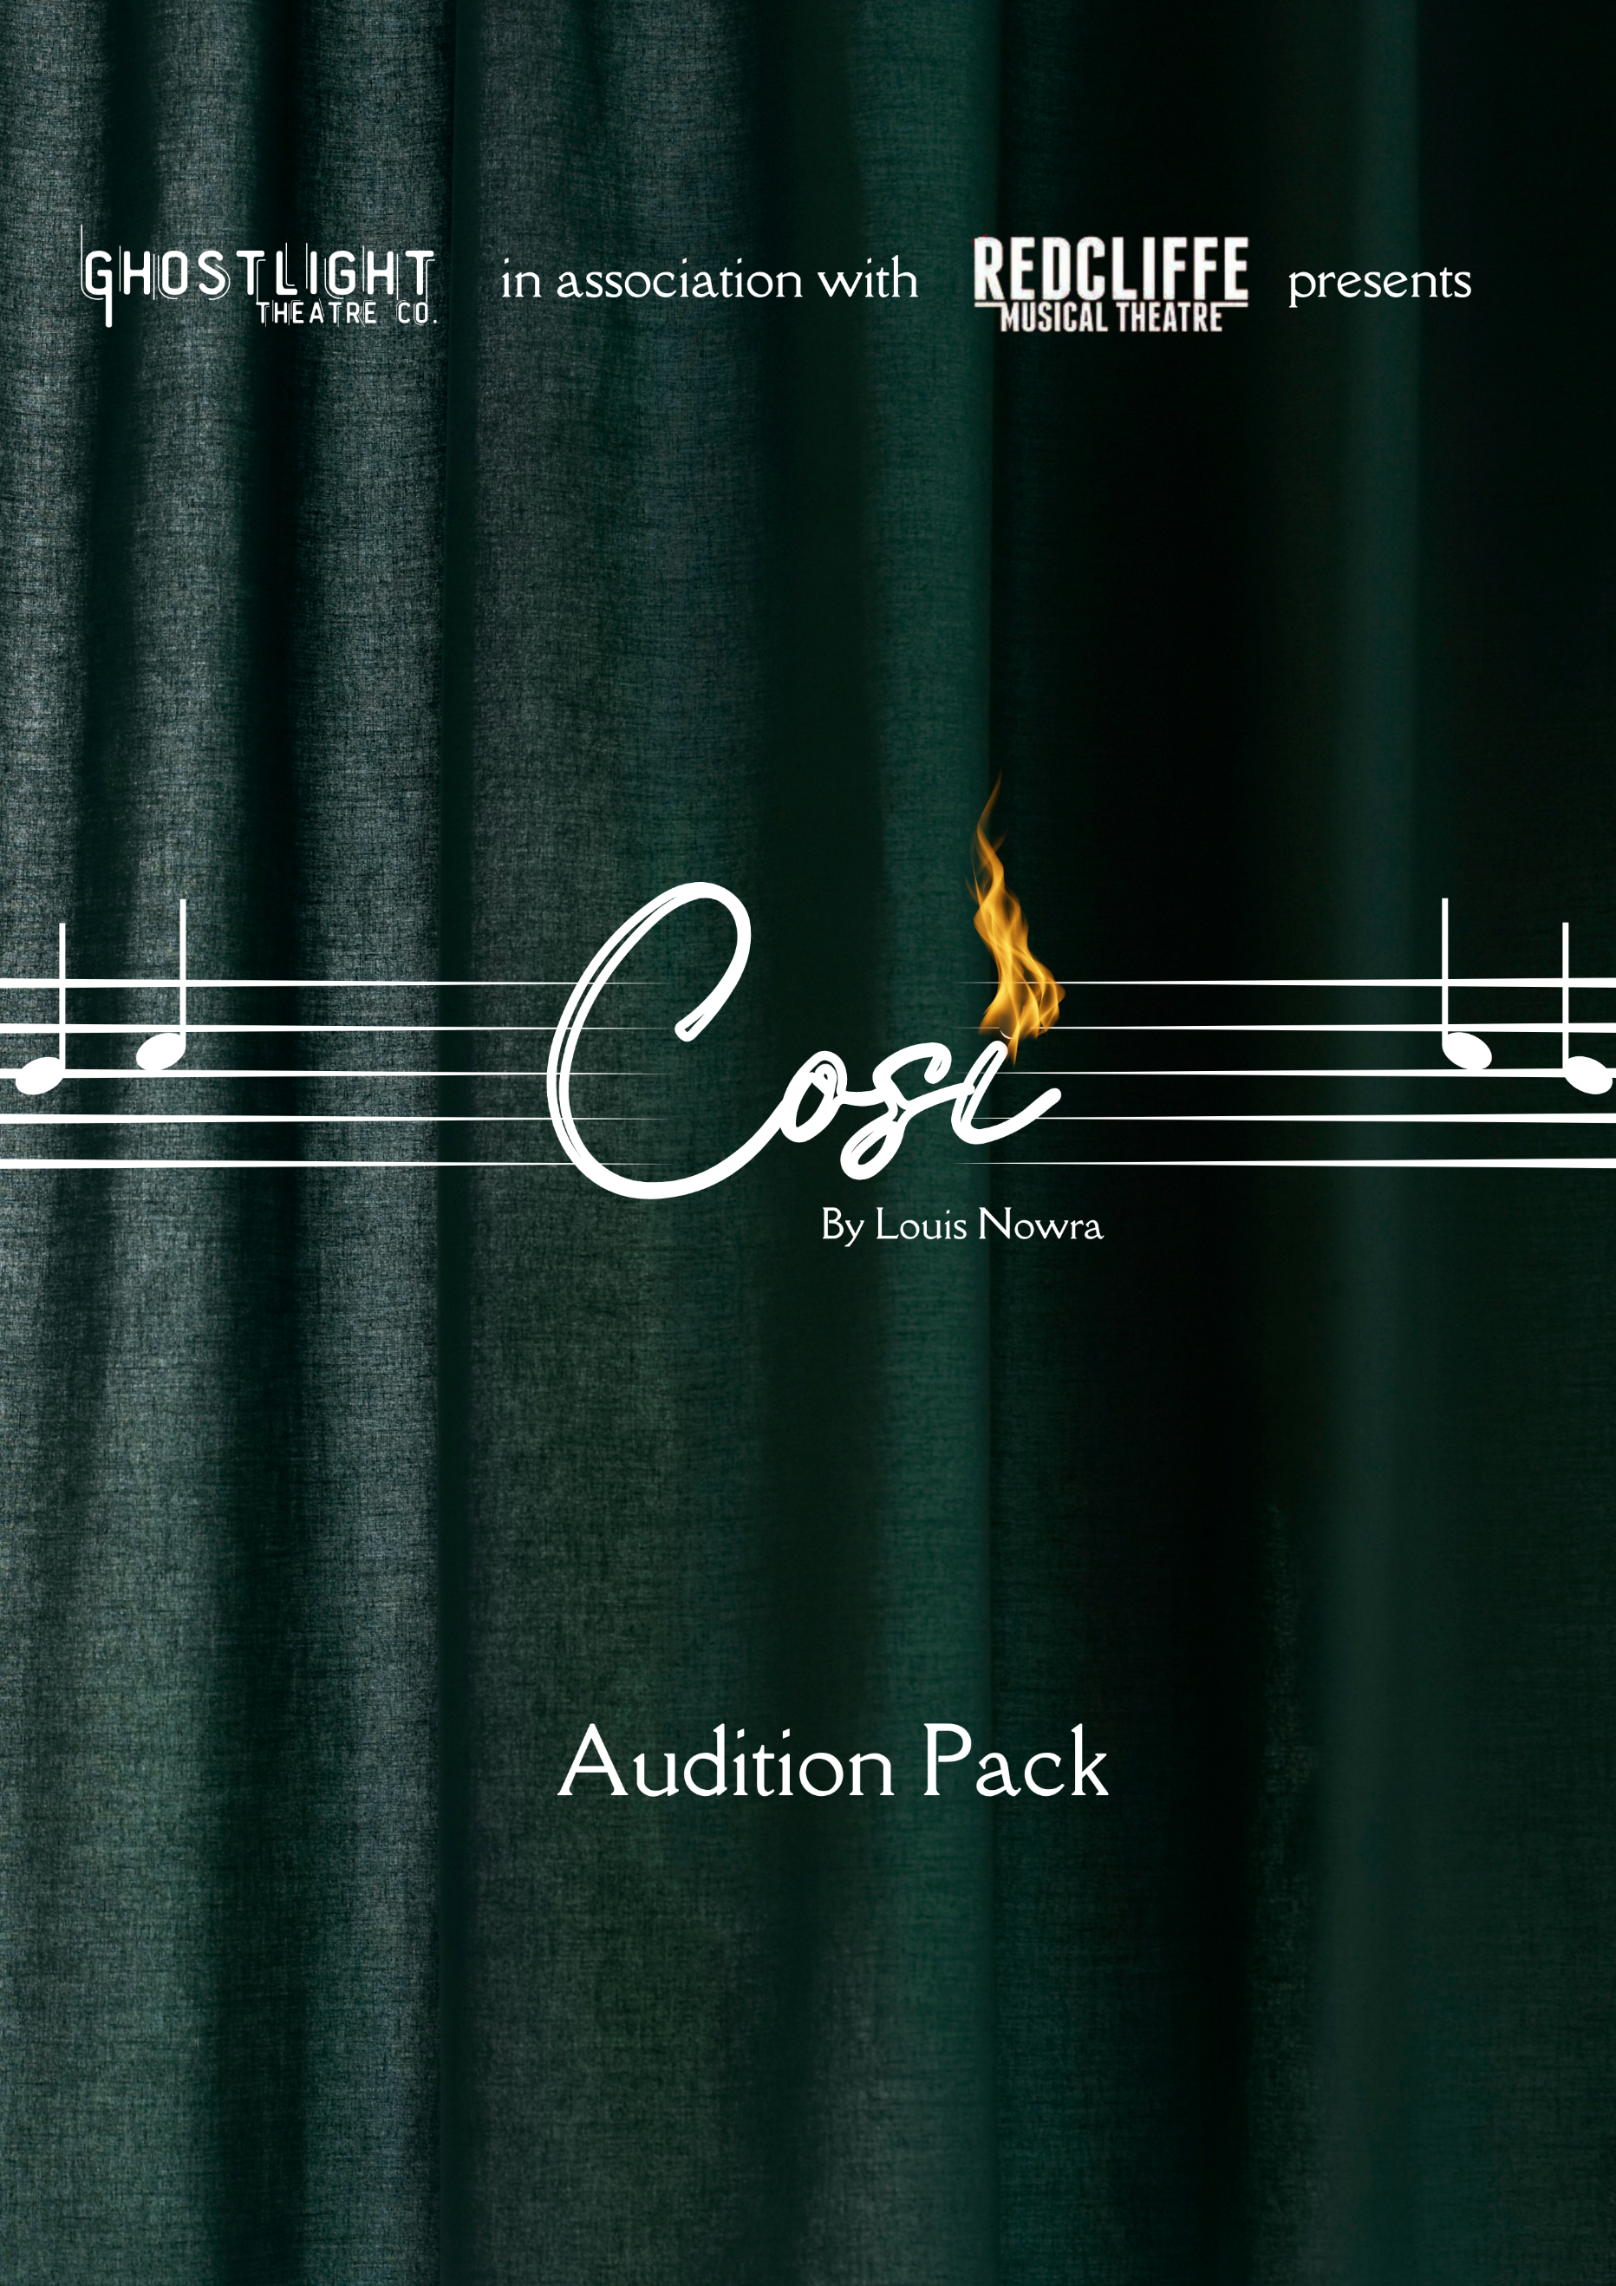

‘COSI’ BY LOUIS NOWRA | 21st- 30th APRIL 2023 | Theatre 102, REDCLIFFE

AUDITION PACK
We encourage performers of all nationalities, genders and sexual identities to audition for this production.
Ghostlight Theatre Co. is very excited to partner with Redcliffe Musical Theatre for this joint production of the Louis Nowra classic, ‘Cosi’.
Directed by Susan O’Toole-Cridland

PLOT SUMMARY
Set in 1970s Australia, this semi-autobiographical play by Louis Nowra introduces us to an older Lewis (who some audience members may know from Nowra’s earlier play – ‘Summer of the Aliens’). Lewis is now a university graduate who takes on a job of putting on a play – with a colourful cast of patients from a local mental asylum. While Lewis, under the strong influence of girlfriend Lucy and best mate Nick, plans on staging a meaningful play such as the likes of Brecht, his plans are thwarted when he discovers one of these patients has other ideas. An opera. Performed by madmen. In a burnt-out theatre. With just a piano. Oh, and none of them can actually sing.
What could possibly go wrong?

IMPORTANT INFORMATION
- Auditions will be held from 10am on Saturday 7 January 2023 at Theatre 102.
- Callbacks (if required) will be held at 10am on Sunday 8 January 2023 at Theatre 102
- If you are unable to attend in person auditions, video auditions will be accepted.
- Rehearsals will commence in January and be held 7-9.30pm Mondays and Wednesdays and 1-4pm Saturdays (TBC).
- Please check rehearsal and performance dates and list any clashes. If you are unavailable for tech week or any of the performances, please do not audition for this production.
- Rehearsals will be held in Chermside and Redcliffe. Performances will be at Theatre 102 in Redcliffe.
- All successful auditionees will need to become a member of Redcliffe Musical Theatre and pay the $25 membership fee, which will entitle them to a year of membership with the company. They will also automatically become members of Ghostlight Theatre Co.

AUDITION REQUIREMENTS
Please prepare a monologue, no more than two minutes in length, that reflects the personality of the character you are auditioning for in a neutral Australian accent. You may be asked to do a cold read from the script

ROLE DESCRIPTIONS
Lewis (Age 20 – 25) - Lewis is a university graduate who, although he may not realise it, is stuck between being told who he needs to be and who he might want to be. Desperate for money, he takes on the job of directing a show in a mental institution.
Roy (Age 40+) - Roy is a manic depressive with a passion for theatre, a love of music and a VERY open opinion of Lewis’ directing ability - or lack thereof.
Cherry (Age 40+) - Cherry is a lover of food, attention, and flick knives - and now her eyes are set on Lewis.
Ruth (Age 40+) - Ruth struggles to marry her obsessive-compulsive disorder with the concept of reality versus illusion in the world of theatre.
Julie (Age 20 – 25) - Julie is a lost young soul. Once a hairdresser, she was put in the institution by her parents in the hope she can beat her addiction to drugs.
Doug (Age 25+) - Doug is an overly sexualised pyromaniac - with definite mother issues...
Henry (Age 45+) - Henry is an older, quiet man. A lawyer before a nervous breakdown landed him in the institution.
Zac (Age 25+ - must be able to play a musical instrument) - Zac is a drugged-up musician with a passion for Wagner. The ideal accompanist for an opera by Mozart right?
Justin (Age 30+) - Justin is a social worker at the institution and the person behind the idea of the patients doing a show - even better if someone else is directing it!
Lucy (Age 20 – 25) - Lucy is Lewis' girlfriend. Her political and artistic views are more in line with Nick and she is appalled that Lewis would take on such a job as this.
Nick (Age 20 – 25) - Nick is Lewis's best mate and confidante who has strong left-wing ideals that he is not afraid to shout out - despite not always knowing his audience.

Some actors may play multiple roles.

PERFORMANCE DATES (subject to change)
Friday 21 April 2023 – 7.30pm
Saturday 22 April 2023 – 2.00pm and 7.30pm
Sunday 23 April 2023 – 6.00pm
Friday 28 April 2023 – 7.30pm
Saturday 29 April 2023 – 2.00pm and 7.30pm
Sunday 30 April 2023 – 6.00pm

Should you have any questions about the audition or production itself, please contact us at ghostlight_theatre@outlook.com

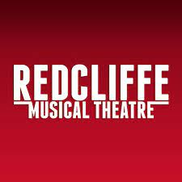
We look forward to seeing you at the audition.

